**Goliath Cloud Monitor**

**Overview**

A cloud-native SaaS offering, Goliath’s Cloud Monitor provides one source for monitoring and troubleshooting performance, availability, and end-user experiences across cloud environments.

Goliath Cloud Monitor provides dashboards, monitors, and alerting with little to no configuration required. Based on the environment type you are monitoring, monitors and dashboards are available out-of-the box so you can begin monitoring your environments right away.

**Dashboards**

The main dashboard displays all of the relevant alert information for your added environments in a single location.

All dashboard widgets are configurable and can be hidden or displayed using the **Configure Widgets**main menu option.

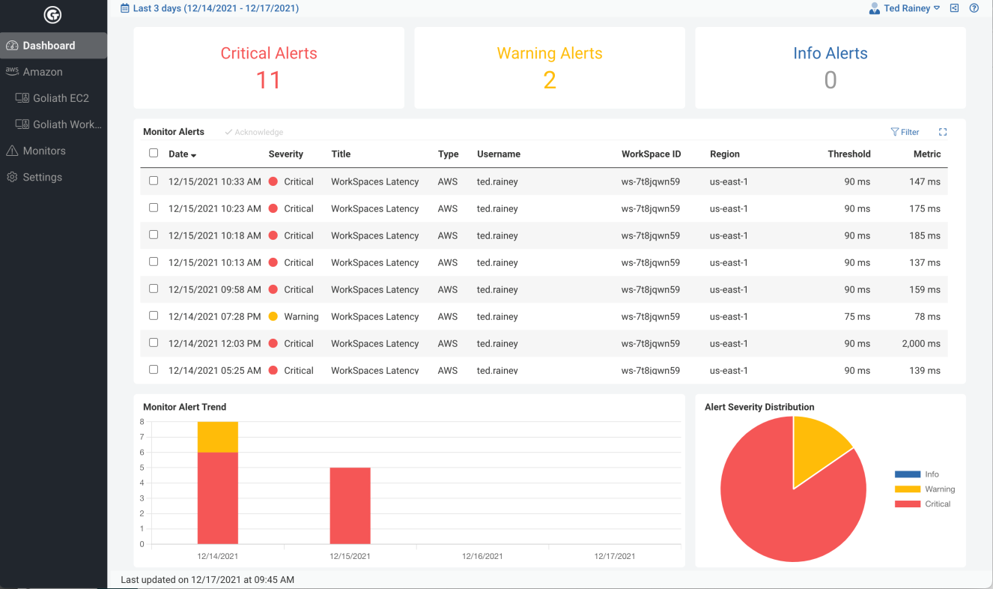

**Figure: Main Dashboard.**

**Adjusting Date Range**

Use the Date Range link in the top left of the dashboard to adjust the time period to display.

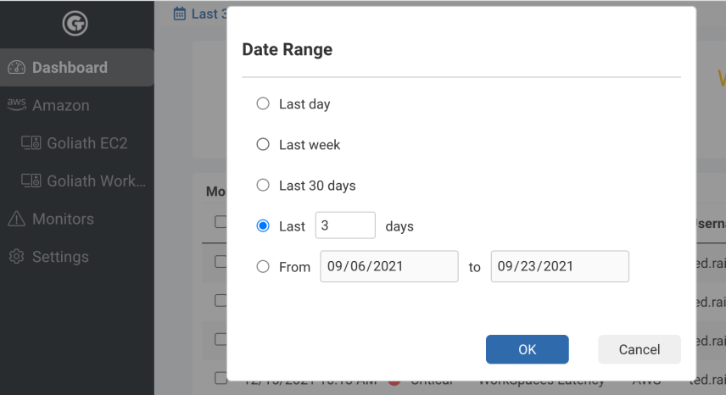

**Figure: Date Range selection dialog.**

**Data Interpretation Threshold Lines**

Intuitive threshold indicator lines are displayed on charts to quickly show you when metrics fall outside of acceptable ranges. The threshold lines can be adjusted by adjusting the associated Monitor threshold ranges (see Monitors, below).

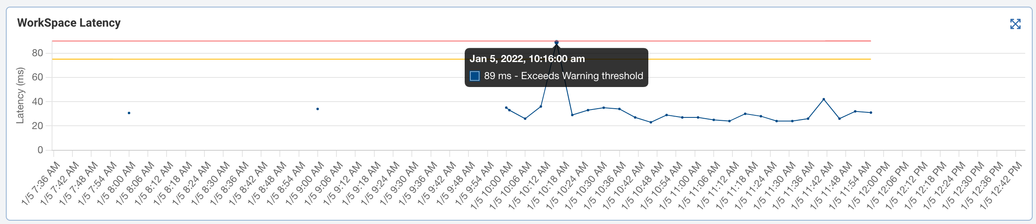

**Figure: Threshold indicators displayed on a dashboard chart.**

**Main Menu**

The main menu is accessible by clicking the down arrow next to your user name. Use this menu to customize your current dashboard, update your password, sign out of Multi-Cloud Monitor, and for Owner accounts, view Billing details.

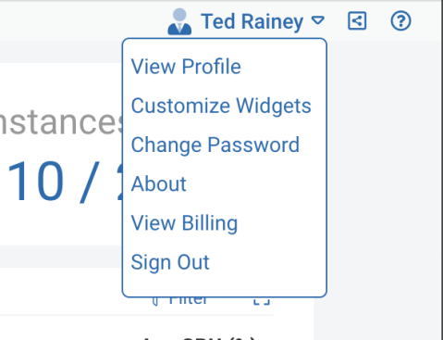

**Figure: Main Menu.**

**Sharing Data and Dashboards**

You can quickly share links to any dashboard page with other users by clicking the Share icon mceclip0.pnglocated in the top right corner of each page.

A link to the page is copied to the clipboard so you can then paste it into email, chat or other text communication to quickly share specific areas of the product.

**Monitors**

Relevant monitors are available out of the box for all added environments. Each individual monitor can be edited to adjust thresholds to fit your specific requirements and environment.

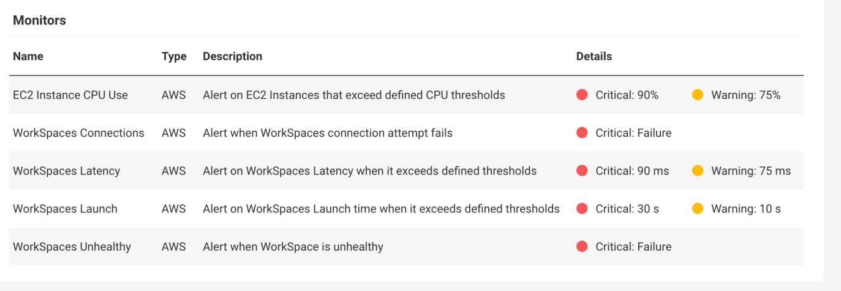

**Figure: Monitors page.**

When a monitor is triggered, whether due to a metric exceeding threshold or an event occurring, an alert is generated. Different alert types apply to monitors with thresholds.

All alerts are captured and displayed on the main dashboard. In addition, alerts will trigger notifications that can be configured in the Settings area.

**Adjusting Threshold Lines**

Monitor thresholds are also used to adjust the threshold lines that appear on some of the dashboard charts when in focus (mouse over the chart to display threshold lines).



**Figure: WorkSpace Latency thresholds.**

**Settings**

From the Settings area, you can manage user accounts, environments, and notifications.

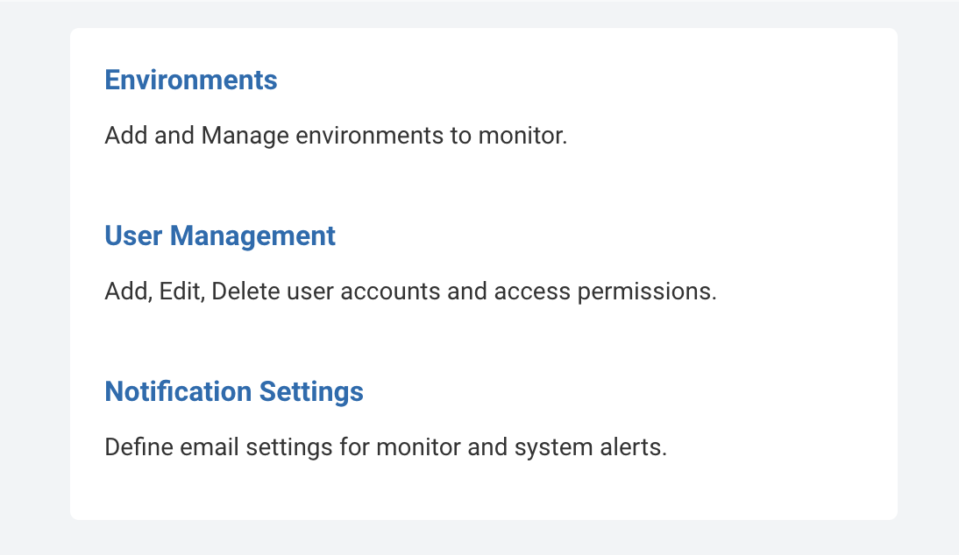

**Figure: Settings options.**

**Environments**

Use the Environments area to manage the environments you are monitoring.

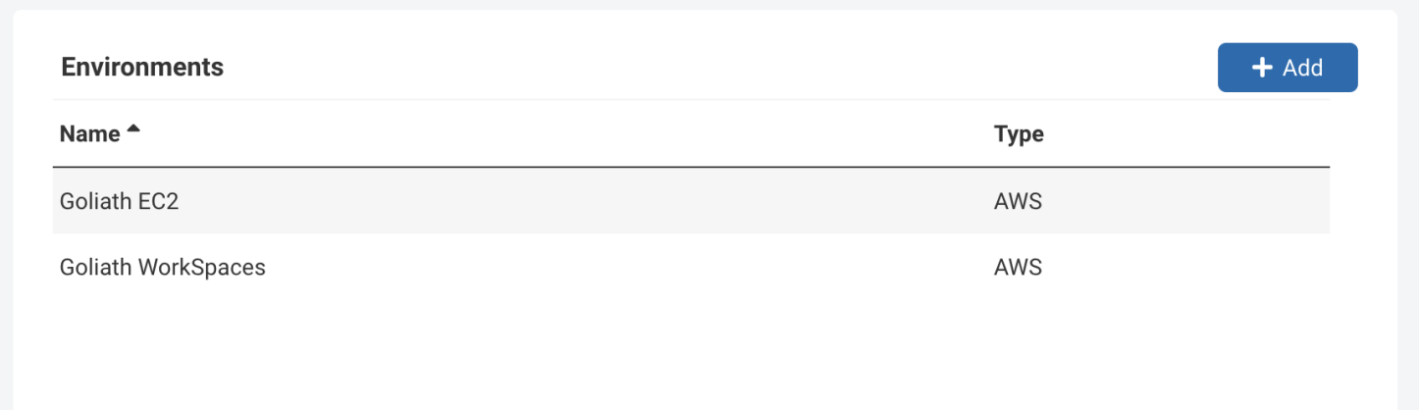

**Adding a New Environment**

* Click **Add**to open the Add Environment dialog.
* Select the type of Environment to add, then include the required parameters. These options will differ based on your environment type (AWS, Azure, Google Cloud).
* For Adding an AWS Environment, see:  
  [Adding an AWS Environment](https://support.goliathtechnologies.com/hc/en-us/articles/4405475026711)

**User Management**

Add and manage user accounts with access to Goliath Multi-Cloud Monitor using the User Management area.

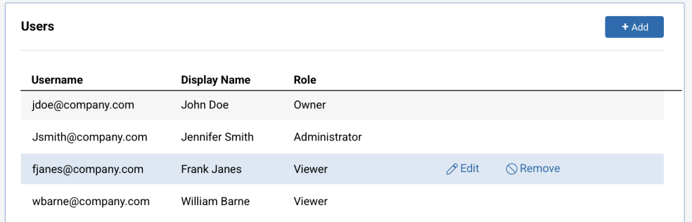

**Figure: Users.**

**User Roles**

Three role levels are available:

**Owner -**Full access to all areas of the product, including billing. At least one Owner account is required.

**Administrator -**Access to all areas of the product, with the ability to manage environments and users. No access to Billing options.

**View -**Read-only access to dashboards and monitors. No access to settings or billing options.

**Notification Settings**

To receive email alert notifications, notifications must be enabled within the Notification Settings area.

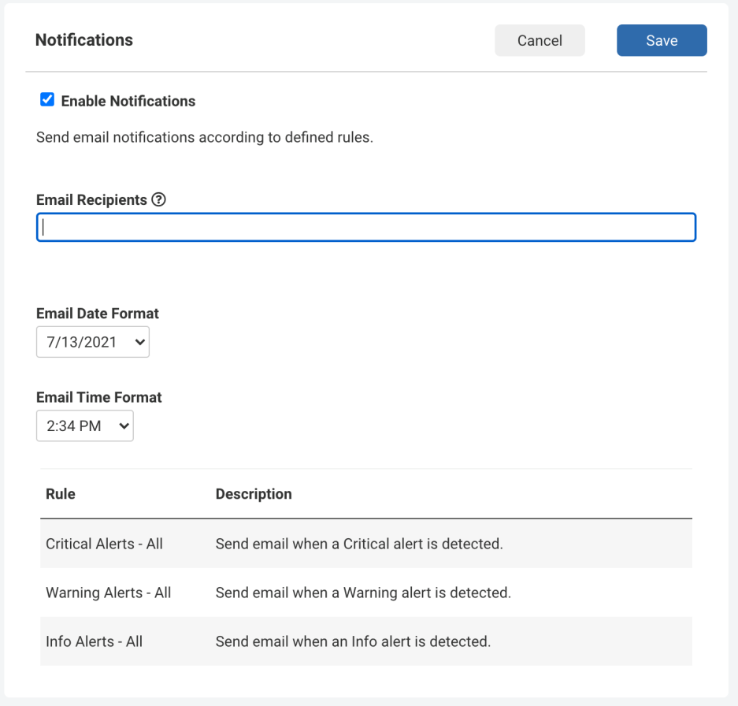

**Figure: Notifications area.**

**Enabling/Disabling Notifications**

* In the Notifications area, use the **Enable** **Notification** checkbox to enable or disable all notifications.
* Use the **Email Recipients**text box to enter a comma-delimited list of email addresses that should receive all notifications.
* To receive only certain alert types as notifications, edit one of the pre-defined rules. For example, to only receive Critical Alert notifications, click the **Critical** **Alerts** **-** **All** rule in the rule table. In the dialog that opens, add your email address then click **Save.**